Chi-Square Test
This is the formula for Chi-Square:
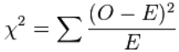
- O = the Observed (actual) value
- E = the Expected value
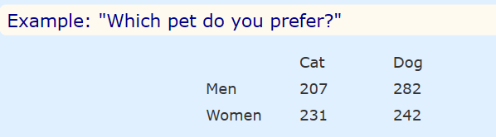
This test only works for categorical data (data in categories), such as Gender {Men, Women} or color {Red, Yellow, Green, Blue} etc, but not numerical data such as height or weight.
Hypothesis: A statement that might be true, which can then be tested.
The two hypotheses are.
- Gender and preference for cats or dogs are independent.
- Gender and preference for cats or dogs are not independent.

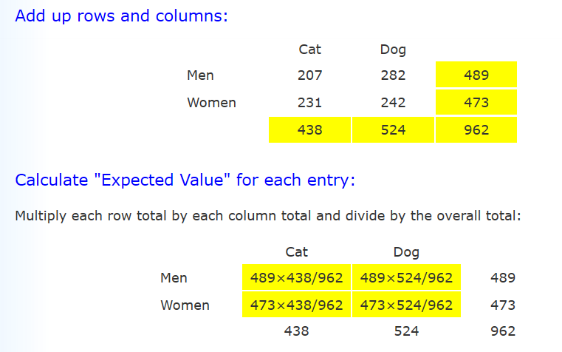
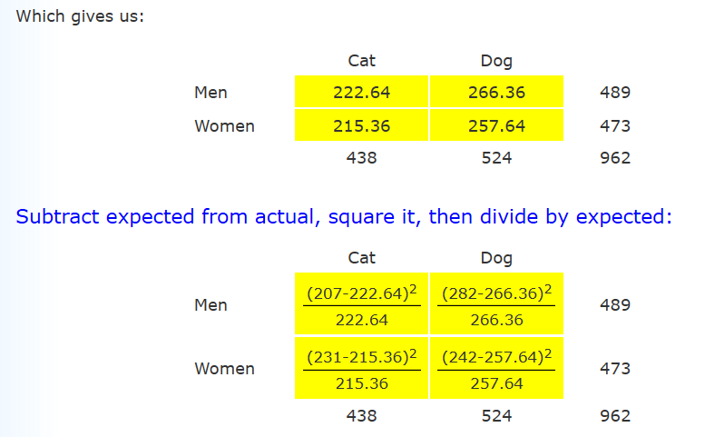
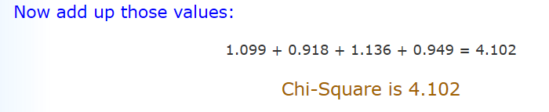

Calculate Degrees of Freedom
Multiply (rows − 1) by (columns − 1)
Example: DF = (2 − 1)(2 − 1) = 1×1 = 1

Result
The result is:
p = 0.04283
In this case p < 0.05, so this result is thought of as being "significant" meaning is that the variables are not independent.
In other words, because 0.043 < 0.05 so Gender is linked to Pet Preference (Men and Women have different preferences for Cats and Dogs).

